The Islamia University of Bahawalpur


Department of Information Technology

SOFTWARE REQUIREMENTS SPECIFICATION
(SRS DOCUMENT)

for

University FAQs Chatbot

Version 1.0

By

Muhammad Arbab
S23BINFT1NM01033
Session Spring 2023 – 2027

Supervisor
Mr. Munawar ahmad

Bachelor of Information Technology
​​
Table of Contents

Revision History 3
Application Evaluation History 4
Introduction 5
Purpose 5
Scope 5
Overall Description 5
Product Perspective 5
Operating Environment 6
Design and Implementation Constraints 6
Requirement Identification Techniques 6
Use Case Diagram 7
Use Case Description 8
Functional Requirements 10
Functional Requirement 1 10
Functional Requirement 2 11
Non-Functional Requirements 11
Usability 11
Performance 12
References 12

Revision History

Name | Date | Reason for changes | Version

Application Evaluation History

Comments (by committee)  *Include the ones given at scope time both in doc and presentation Action Taken | Action Taken

Supervised by:
<Mr. Munawar Ahmad>

Signature_____________

Introduction

This project, University FAQ Chatbot, is designed to provide an intelligent assistant that automatically responds to user queries related to university information. The system uses Natural Language Processing (NLP) to understand user questions and retrieve accurate answers from a predefined FAQ database. It aims to improve communication between the university and its stakeholders while reducing manual workload.

Purpose

The purpose of this Software Requirements Specification (SRS) is to define the functional and non-functional requirements of the University FAQ Chatbot.
The system is designed to:
- Provide quick and accurate responses to frequently asked questions
- Reduce workload on university staff
- Improve user experience through a simple interface
- Serve students, faculty, and visitors efficiently
- Ensure reliable and consistent information delivery
Scope
The scope of this project includes developing a chatbot that retrieves answers strictly from a predefined FAQ database. The system will allow users to search queries in natural language and receive relevant responses.
The chatbot will:
- Handle repetitive queries
- Provide accurate information
- Be accessible via web or mobile platforms
It will not generate answers outside the database.

Overall Description
The system is a web-based chatbot that interacts with users and provides instant answers. It supports both admin and end users. Admins manage FAQs, while users retrieve information through the chatbot interface.
The system enhances efficiency and ensures users get quick responses without manual intervention.
Product Perspective
The University FAQ Chatbot is a standalone system but can integrate with:
- University website
- Mobile applications
It uses APIs for communication and connects to a centralized database for FAQ storage.

Operating Environment

The system will operate in:
- Web browsers (Chrome, Edge, etc.)
- Mobile devices (Android/iOS via browser or app)
- Technologies used:
- Frontend: HTML, CSS, JavaScript
- Backend: Django (Python)
- Database: MySQL

Design and Implementation Constraints
• Must work efficiently on different devices
• Requires internet connection for API/database access
• Security constraints (authentication, encryption)
• Limited to FAQ database responses only
• Time and budget limitations

Requirement Identification Techniques
The system requirements are identified using Use Case technique, as it is suitable for interactive systems like chatbots.
This helps in:
- Understanding user interaction
- Defining system behavior
- Structuring functional requirements

Use Case Diagram
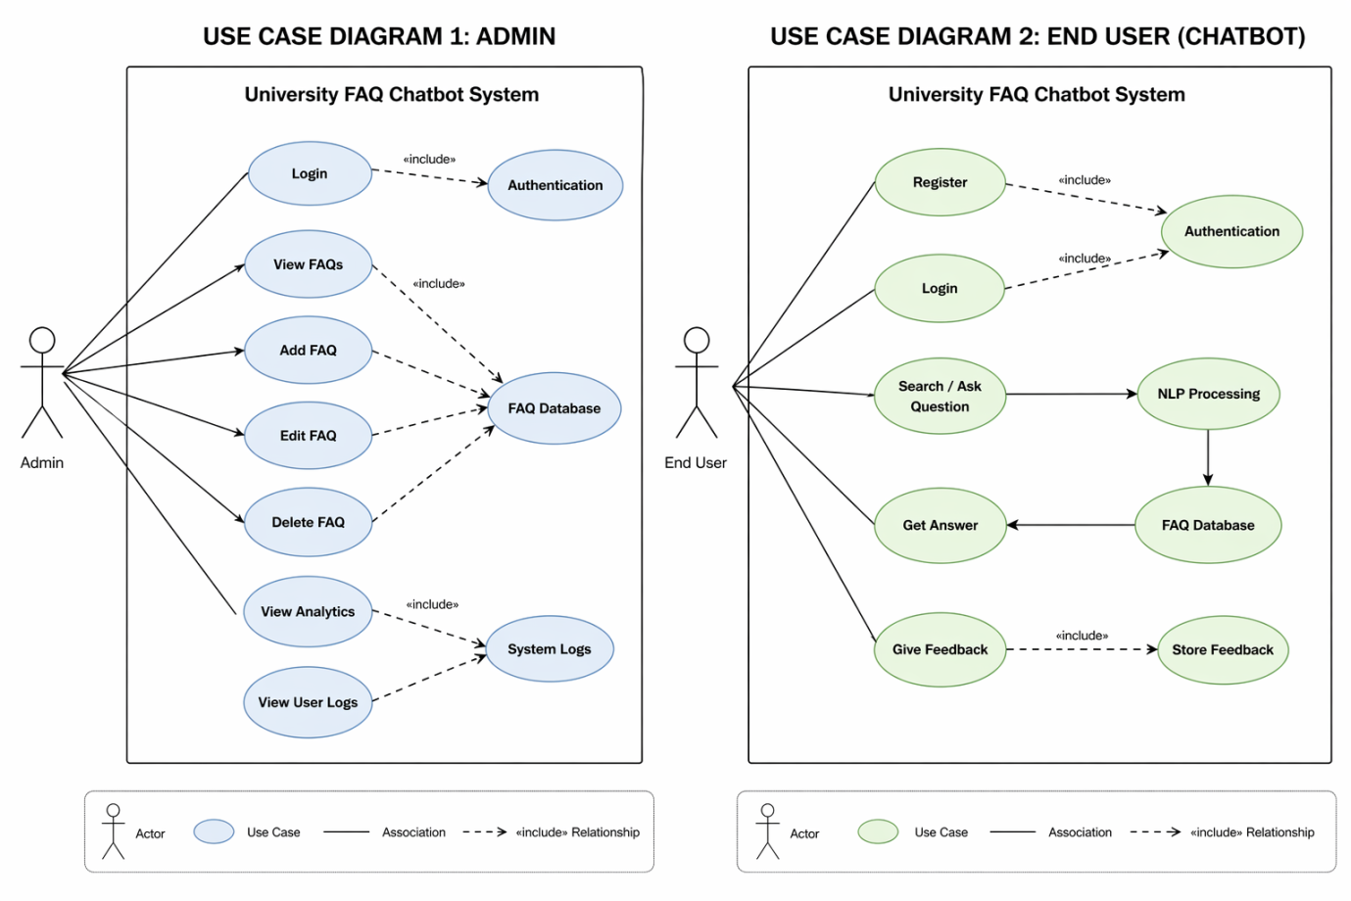

Use Case Description
UC-1

Use Case ID: | UC-1
Use Case Name: | Admin Dashboard & FAQ Management
Actors: | Admin
Description: | Admin manages FAQ content and monitors system activity.
Trigger: | Admin logs into the system
Preconditions: | - Admin must have valid credentials
Postconditions: | • FAQs are updated  • System logs and analytics are accessible
Normal Flow: | • Admin logs in  • Views FAQs  • Adds/edits/deletes FAQs  • Checks analytics and logs
Alternative Flows: | None
Exceptions: | None
Business Rules | - Only authorized admins can access dashboard

UC-2

Use Case ID: | UC-2
Use Case Name: | FAQ Retrieval and Search
Actors: | End User
Description: | User interacts with chatbot to get answers
Trigger: | User enters a query
Preconditions: | • System is active  • FAQs exist in database
Postconditions: | • Answer is displayed  • Query is logged
Normal Flow: | • User enters query  • NLP processes input  • System searches database  • Answer is displayed
Alternative Flows: | • No match → suggest similar FAQs  • No result → escalate query
Exceptions: | • Invalid query  • System error  • Empty database

Functional Requirements
Functional requirements define what the system must do. They describe the core features and operations of the chatbot, such as user login, searching FAQs, retrieving answers, and managing data. These requirements ensure the system performs all necessary tasks to meet user needs.

Functional Requirement 1

Identifier | FR-1
Title | Admin Login
Requirement | System must allow admin to securely log in
Source | Design Doc
Rationale | Ensures authorized access
Dependencies | None
Priority | High

Functional Requirement 2

Identifier | FR-2
Title | Manage FAQs
Requirement | Admin can add, edit, delete, and view FAQs
Source | Game Design
Rationale | Maintains updated database
Dependencies | None
Priority | High

Functional Requirement 3

Identifier | FR-2
Title | Retrieve Answer
Requirement | System displays most relevant answer
Rationale | Core chatbot functionality
Priority | High

Functional Requirement 4

Identifier | FR-2
Title | Search FAQ
Requirement | User can search queries using text
Rationale | Core chatbot functionality
Priority | High

Functional Requirement 5
Identifier | FR-2
Title | User Feedback
Requirement | User can provide feedback on responses
Rationale | Core chatbot functionality
Priority | Medium

Non-Functional Requirements
Non-functional requirements define how the system should perform. They focus on quality aspects like performance, security, usability, reliability, and scalability. These ensure the system runs efficiently, securely, and provides a smooth user experience.

Usability
- Interface must be simple and user-friendly
- Easy navigation for both admin and user
- Responsive design for all devices
Performance
- System should respond within seconds
- Handle multiple users efficiently
- Optimize database queries

Security
- User data must be encrypted
- Admin login must be secure (MFA recommended)

Reliability
- System should have high uptime
- Provide fallback messages during failure

Scalability
- System should support future expansion
- Easy addition of FAQs and users

References
- Speech and Language Processing – Jurafsky & Martin
- Chatbot Technology Review – Adamopoulou
- Django Documentation
- NLTK Documentation
- Zendesk Answer Bot

